- Molokini and Turtle Reef Snorkel ($105.00~)
This trip provides a comfortable, safe ocean excursion from Lahaina to Molokini aboard a 65’ luxury yacht. The maximum capacity for this vessel is 149 passengers, but only 95 passengers are ever booked. This enables the crew to offer you personalized attention and assistance. Once you arrive at Molokini you’ll snorkel alongside tropical fish and embark on a memorable underwater discovery, viewing the incredible marine life the crater has to offer. From there, you will visit Turtle Reef, where friendly sea turtles frolic and await your company. A Water Trampoline makes for a fun and amusing time. Snorkel gear included.
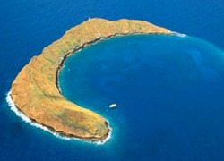

2. Enjoy a 2 Hour Sunset Maui Kayak Trip （$60.00~）
You will enjoy this unique two hour kayak adventure that combines a late afternoon paddling followed by one of Maui’s magnificent sunsets. As you take pleasure in watching the sunset you can’t help but enjoy Maui’s scenic landscape on one side and neighboring islands on the other side. What better way to end another perfect day on Maui
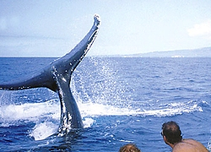

3. Maui's Exciting Whale Watch Rafting Excursion ($60.00~)
This 2 hour rafting excursion is the most “Exciting” Whale Watch experience offered on Maui. The vessel is a 30 foot ridged hulled inflatable raft Certified for 24 passengers, however only 18 passengers are allowed to assure maximum comfort and a quality Whale Watch experience. Researchers currently studding the Humpback Whales will provide an informative narration throughout the trip. The Captains take great pride in positioning the vessel for optimum photo opportunities and viewing. Not only are you guaranteed to see whales, you will get as close as legally possible to these wonderful and fascinating creatures. This Whale Watch departs from West Maui and offered daily from 7:00 am to 5:00 pm. Private Charters are available (2 hour minimum).

